Project Sprint #1

The Solitaire game is described in CS449HomeworkOverview. You should read the description very carefully.

In this assignment, you aim to specify the requirements (i.e., user stories and acceptance criteria) of the target software that allows a human player to play a Solitaire game. These requirements will be fully implemented by the end of sprint 3. The minimum features include choosing the board size and type, starting a new game, making a move, determining if a game is over. The following is a sample GUI layout.

Board size
7
Board Type  - English  - Hexagon  - Diamond | 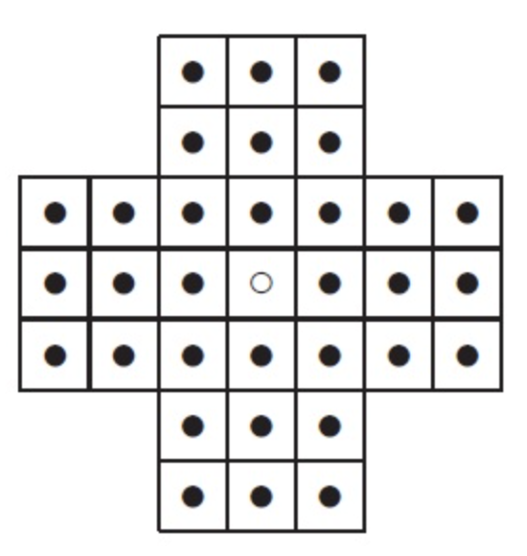 | New Game
Figure 1. Sample GUI layout of the first working program by the end of Sprint 3

Use the following tables to document your user stories and acceptance criteria.

You are required to use the free ChatGPT or another LLM to complete two user stories and two of their respective acceptance criteria. You must ensure that the generated user stories are correct and fix them if not. At the end of the submission, provide screenshots of your LLM prompts and answers, along with the description of errors the LLM made that you had to correct. Points will be deducted if no screenshots/description are provided.

For the other user stories and acceptance criteria, you are not required to use LLM.

- User Stories (3 points)

- User Story Template: As a <role>, I want <goal> [so that <benefit>]

ID | User Story Name | User Story Description | Priority | Estimated effort (hours)
1 | Choose a board size | As a player, I want to be able to choose the board size so that I can play Peg Solitaire at the board size I want. | High | 1-2
2 | Choose the board type | As a player, I want to be able to choose the board type so that I can play Peg Solitaire on the board shape I want. | High | 2-3
3 | Start a new game of the chosen board size and type | As a player, I want to be able to start a new game with the chosen board size and type so that I can play Peg Solitaire in my desired configuration. | High | 3-4
4 | Make a move in a game | As a player, I want to be able to make a valid and legal move in the game so that I can play the game and attempt to win. | High | 6-8
5 | A game is over | As a player, I want to know when there are no more legal moves to make so that I can know if I won or lost the game. | High | 3-4

- Acceptance Criteria (AC) (12 points): Add/delete rows as needed.

User Story ID and Name | AC  ID | Description of Acceptance Criterion | Status (completed, toDo, inPprogress)
1. Choose a board size | 1.1 | AC 1.1 Displaying the available board sizes.  Given the Peg Solitaire game is open and running  When the player views the board size control  Then the application will display the boards available to choose supported by the game | toDo
1. Choose a board size | 1.2 | AC 1.2 Selecting the board’s size  Given the valid board sizes are displayed  When the player selects one of the available board sizes  Then the selected board size will appear as selected | toDo
1. Choose a board size | 1.3 | AC 1.3 Default board size  Given the choice of the board sizes  When the user doesn’t choose a specific board size  Then default to the standard board size of 7 | toDo
2. Choose the board type | 2.1 | AC 2.1 Displaying the available board types  Given the Peg Solitaire application is open  When the player views the board type selection control  Then the application displays English, Hexagon, and Diamond as the available board types | toDo
2. Choose the board type | 2.2 | AC 2.2 Selecting the board’s type  Given the choice of board types  When the player selects one of the available board types  Then the selected board type will appear as selected | toDo
2. Choose the board type | 2.3 | AC 2.3 Default Board Type  Given the choice of board types  When the player doesn’t select one of the available board types  Then the selected board type will default to English | toDo
3. Start a new game of the chosen board type and size | 3.1 | AC 3.1 Start a new game  Given the player has selected a board size and type  When the player selects new game  Then the application starts a new Peg Solitaire game with the selected board size and type | toDo
3. Start a new game of the chosen board type and size | 3.2 | AC 3.2 New game resets the previous game  Given a game is in progress  When the user selects new game  Then the current game is discarded, and a new board is created using the selected board size and type | toDo
3. Start a new game of the chosen board type and size | 3.3 | AC 3.3 Initializing the board  Given the player has started a new game  When the new board is displayed  Then the new game is configured in the appropriate layout for the selected type and has the appropriate starting peg configuration | toDo
4. Make a move in the game | 4.1 | AC 4.1 Making a legal move  Given the game has been started and a legal move is available  When the player selects an appropriate move  Then the application moves the selected peg to the destination, removes the jumped peg, and updates the board | toDo
4. Make a move in the game | 4.2 | AC 4.2 Making an invalid move  Given the game has been started  When the user tries to make an illegal move  Then the application does not perform the move and notifies the user that the move they tried to make cannot be done | toDo
4. Make a move in the game | 4.3 | AC 4.3 Updating the board appropriately  Given the player has made a legal move  When the move is completed  Then the board will update and display itself accordingly to the user | toDo
5. The game is over | 5.1 | AC 5.1 Detecting a winning game  Given the game is in progress  When the player makes a move to leave them with one peg remaining  Then the player has won the game, and it is completed | toDo
5. The game is over | 5.2 | AC 5.2 Detecting a losing game  Given there is more than one peg left on the board  When there are no more legal moves  Then the player has lost the game, and it is completed | toDo
5. The game is over | 5.3 | AC 5.3 Detecting an in-progress game  Given there is more than one peg left on the board  When there is at least one legal move  Then the game is not over, and the player can keep playing | toDo

ChatGPT conversation
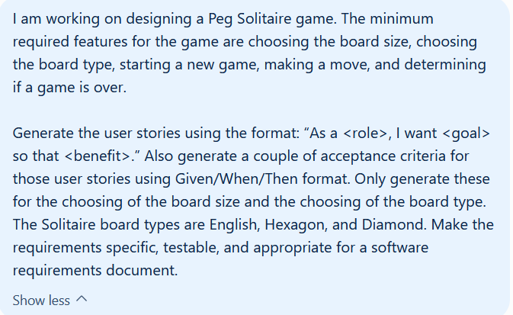
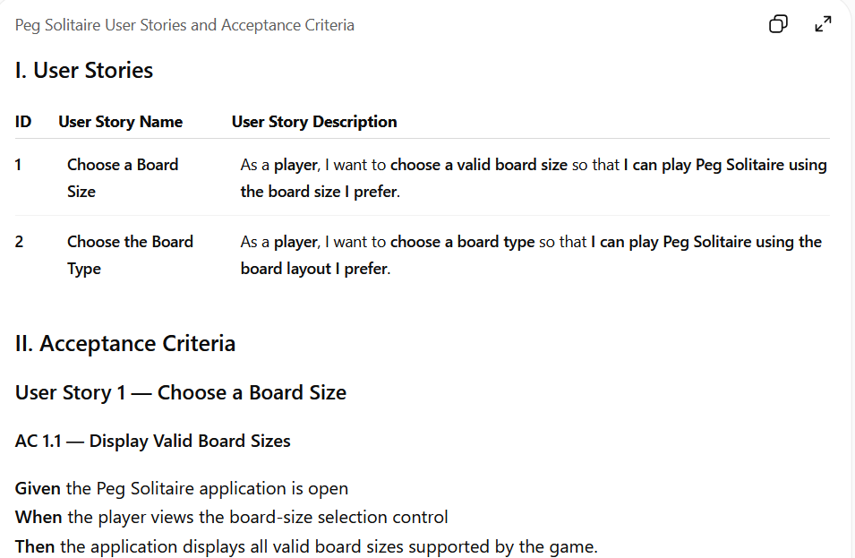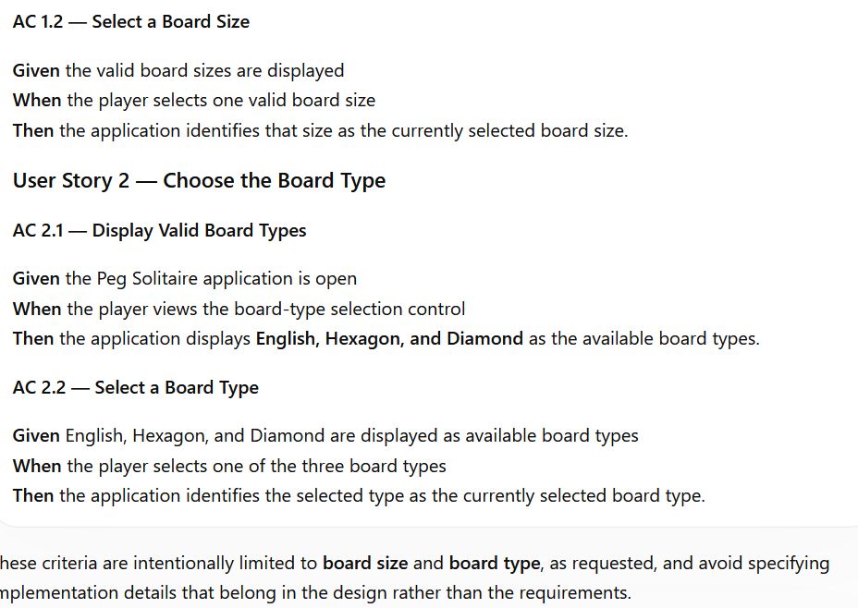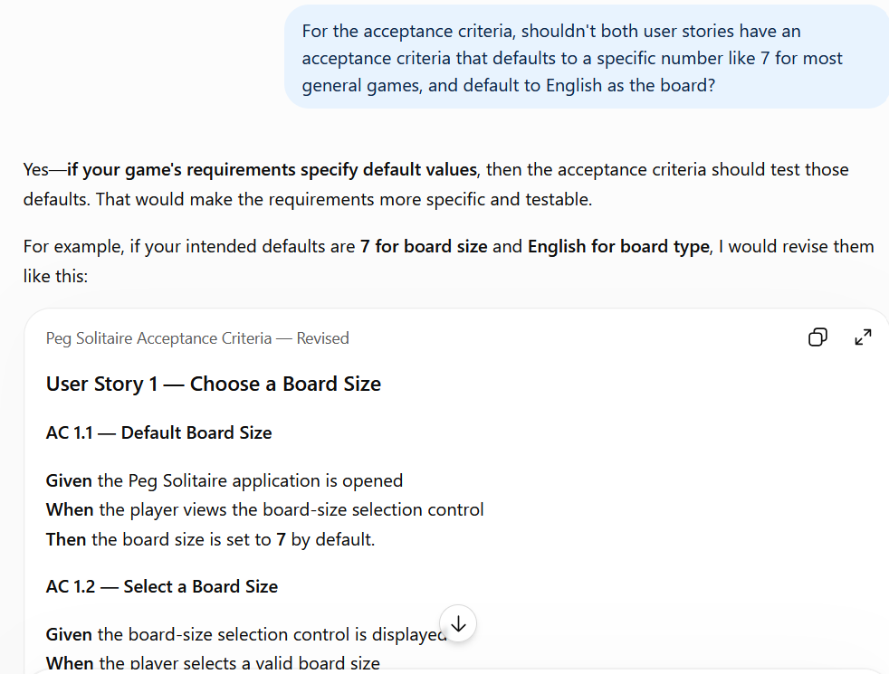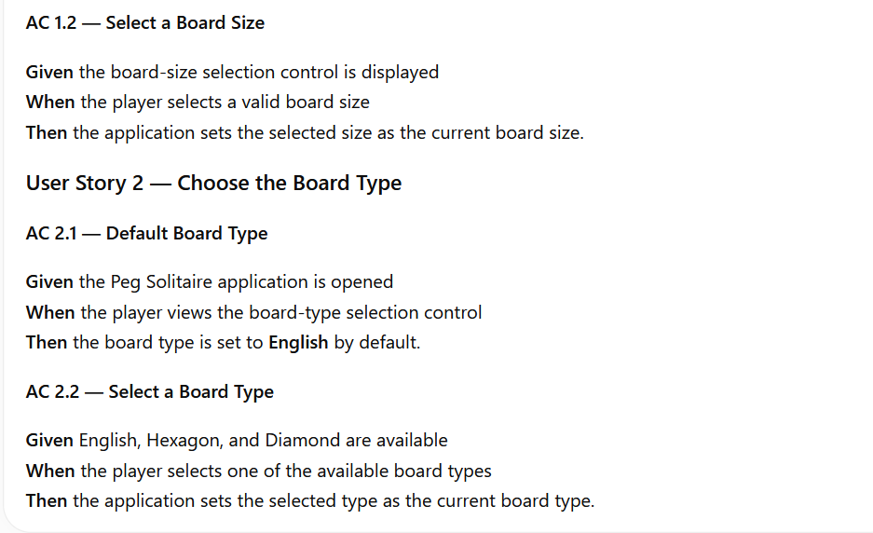
For this, I decided to use both the reponses it gave me before and after I asked it about using dafaults. The befores are great and having the defaults are great as well, so getting both in makes the most logical sense.

